TO WHOM IT MAY CONCERN

04th January 2006

Dear Sirs,

The Guide Association (Incorporated by Royal Charter)
Period of Insurance: 1st January 2006 to 31st December 2006
We act as Insurance Brokers for the above client and confirm that Insurance is in place in respect of Public and Products Liability up to £20,000,000 any one loss under the following policies: -

Public and Products Liability
Policy Number 04055F06AB issued by Mitsui with a limit of £1,000,000 any one occurrence or series of occurrences consequent on one original cause, unlimited during the period, but £1,000,000 in the aggregate in respect of Products Liability.

This Insurance arranged for the period 12 months at the 1st January 2006 provides indemnity to the following organisations and/or persons: -

(I) The Guide Association and all its Members including Branch Associations, and British Guides in Foreign Countries and Administrative Units

(ii) The Friends of Guiding

(iii) The Trefoil Guild

(iv) The Link International Fellowship

(v) Officers and Officials of any of the foregoing

(vi) Any employee of the Guide Association

(vii) Any British guide operating abroad under the jurisdiction of the Guide Association

(viii) Any person not acting as a member of another organisation who is authorised to be in charge of or supervise or otherwise assist in Guiding activities

(ix) Children of Members of the above whilst their parents are involved in Guiding activities

- Prospective Members of the Guide Association (prior to taking the promise)
- Guide Association members of the Student Scout and Guide Organisation.

- Page 2 -

(xii) The Guide Association Trust Corporation

(xiii) The Trustees of and/or members of the Committee responsible for the management of any property or premises belonging to or leased to Trustees for any unit

(xiv) Guides Cymru

The policy indemnifies the Insured in connection with accidents occurring in respect of Guiding activities within Great Britain, Northern Ireland, The Channel Islands, The Isle of Man and overseas, including Branch Association Countries and in respect of BGIFC units and members.

Cover includes Indemnity to Principals.

The policy provides for cross liabilities, Health and Safety at Work Act, Defective Premises Act, Occupiers Liability Act and liability arising for Death and Bodily injury to passengers being carried on Carnival Floats.

Excess Public and Products Liability 1st Layer
Policy Number 0024580579 issued by AIG Europe with a limit of £9,000,000 any one occurrence or series of occurrences consequent on one original cause, unlimited during the period but £9,000,000 in the aggregate in respect of Products Liability

IN EXCESS OF £1,000,000 any one occurrence or series of occurrences consequent on one original cause, unlimited during the period but £1,000,000 in the aggregate in respect of Products Liability.

Policy Wording Matches underlying terms.

Excess Public and Products Liability 2nd Layer

Policy Number 46UKA08145 issued by Ace Europe with a limit of £10,000,000 any one occurrence or series of occurrences consequent on one original cause, unlimited during the period but £10,000,000 in the aggregate in respect of Products Liability.

IN EXCESS OF £10,000,000 any one occurrence or series of occurrences consequent on one original cause, unlimited during the period but £10,000,000 in the aggregate in respect of Products Liability.

Policy Wording Matches underlying terms.

We trust this information is adequate for your requirements, however, should you require further details, please do not hesitate to contact us.

Yours faithfully

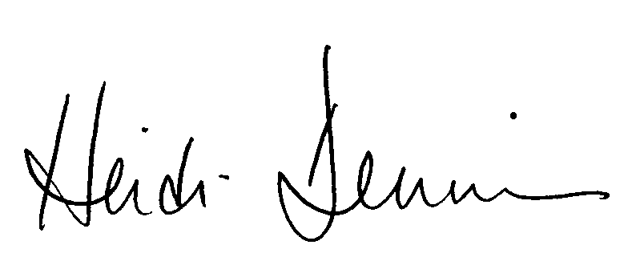

Girlguiding UK Insurance Service

